Experiment No.: 7

HALF ADDER & FULLADDER

AIM: To prepare CMOS layout in selected technology, simulate with & without capacitive load, comment on rise & fall times for Half Adder and Full Adder.

PREREQUISITE:

Students should know the constructs of microwind software.

OBJECTIVES:
- To design Half Adder and Full Adder.
- To implement the design in microwind.
- To simulate the design in microwind.

TOOLS USED:

PROBLEM STATEMENT:

Microwind software with version 3 and above

THEORY:
Design and implement it in microwind for simulation.

Addition is one of the most basic operations performed by different electronic devices like

computers, calculators, etc. The electronic circuit that performs the addition of two or more numbers, more specifically binary numbers, is called as adder. As we know, the logic circuits use binary number system to perform the operations, hence the adder is referred to as binary adder.
Depending on the number of binary digits that a circuit can add, adders (or binary adders) are of two types −
- Half Adder
- Full Adder

HALF ADDER:
A unit which adds together two input variables. A full adder can add a bit carried from another addition as well as the two inputs, whereas a half adder can only add the inputs together.

OPERATION:
Half adder is a combinational arithmetic circuit that adds two numbers and produces a sum bit (S) and carry bit (C) as the output. If A and B are the input bits, then sum bit (S) is the X-
OR of A and B and the carry bit (C) will be the AND of A and B. From this it is clear that a half adder circuit can be easily constructed using one X-OR gate and one AND gate. Half adder is the simplest of all adder circuit, but it has a major disadvantage. The half adder can add only two input bits (A and B) and has nothing to do with the carry if there is any in the input. So if the input to a half adder have a carry, then it will be neglected it and adds only the A and B bits. That means the binary addition process is not complete and that‟s why it is called a half adder. The truth table, schematic representation and XOR//AND realization of a half adder are shown in the figure below.
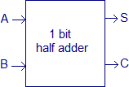
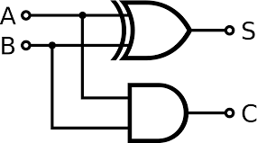

Fig. 4 Schematic of Half Adder Fig. 5 Realization of Half Adder

Truth Table of Half Adder:
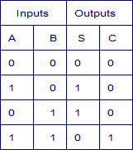
Fig. 6 Truth Table of Half Adder

FULL ADDER:
A combinational logic circuit that can add two binary digits (bits) and a carry bit, and produces a sum bit and a carry bit as output is known as a full-adder.
In other words, a combinational circuit which is designed to add three binary digits and produces two outputs (sum and carry) is known as a full adder. Thus, a full adder circuit adds three binary digits, where two are the inputs and one is the carry forwarded from the previous addition. The block diagram and circuit diagram of the full adder are shown in Figure-1.
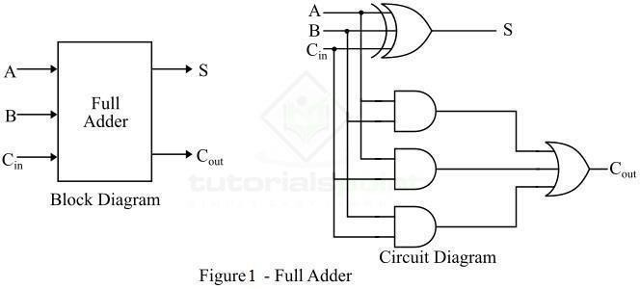
Hence, the circuit of the full adder consists of one EX-OR gate, three AND gates and one OR gate, which are connected together as shown in the full adder circuit in Figure-1.

OPERATION:
Full adder takes three inputs namely A, B, and Cin. Where, A and B are the two binary digits, and Cin is the carry bit from the previous stage of binary addition. The sum output of the full adder

is obtained by XORing the bits A, B, and Cin. While the carry output bit (Cout) is obtained using AND and OR operations.

Truth Table of Full Adder:
Truth table is one that indicates the relationship between input and output variables of a logic circuit and explains the operation of the logic circuit. The following is the truth table of the full-adder circuit
−

Inputs |  |  | Outputs
A | B | C  in | S  (Sum) | Cout (Carry)
0 | 0 | 0 | 0 | 0
0 | 0 | 1 | 1 | 0
0 | 1 | 0 | 1 | 0
0 | 1 | 1 | 0 | 1
1 | 0 | 1 | 0 | 1
1 | 1 | 0 | 0 | 1
1 | 1 | 1 | 1 | 1
1 | 0 | 0 | 1 | 0

Hence, from the truth table, it is clear that the sum output of the full adder is equal to 1 when only 1 input is equal to 1 or when all the inputs are equal to 1. While the carry output has a carry of 1 if two or three inputs are equal to 1.

K-Map for Full Adder:
K-Map (Karnaugh Map) is a tool for simplifying binary complex Boolean algebraic expressions.

The K-Map for full adder is shown.

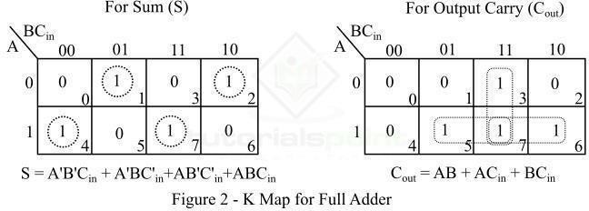

Characteristic Equations of Full Adder
The characteristic equations of the full adder, i.e. equations of sum (S) and carry output (Cout) are obtained according to the rules of binary addition. These equations are given below −
The sum (S) of the full-adder is the XOR of A, B, and Cin. Therefore,
Sum, S=A⊕B⊕Cin S=A′B′Cin+A′BC′in+AB′C′in+ABCinSum,S=A⊕B⊕Cin=A′B′Cin+A′BCin′+AB′Cin′+ABCin The carry (C) of the half-adder is the AND of A and B. Therefore, Carry,C=AB+ACin+BCinCarry,C=AB+ACin+BCin

Advantages of Full Adder
The following are the important advantages of full adder over half adder −
- Full adder provides facility to add the carry from the previous stage.
- The power consumed by the full adder is relatively less as compared to half adder.
- Full adder can be easily converted into a half subtractor just by adding a NOT gate in the circuit.
- Full adder produces higher output that half adder.
- Full adder is one of the essential part of critic digital circuits like multiplexers.
- Full adder performs operation at higher speed.

Applications of Full Adder
The following are the important applications of full adder −

- Full adders are used in ALUs (arithmetic logic units) of CPUs of computers.
- Full adders are used in calculators.
- Full adders also help in carrying out multiplication of binary numbers.
- Full adders are also used to realize critic digital circuits like multiplexers.
- Full adders are used to generate memory addresses.
- Full adders are also used in generation of program counterpoints.
- Full adders are also used in GPU (Graphical Processing Unit).

PROCEDURE:

- Select PMOS & NMOS devices from palette.
- Connect source terminal of PMOS P1 & source terminal of PMOS P2 with metal 2 and give VDD Supply.
- Connect drain terminal of PMOS P1 & drain terminal of PMOS P2 with metal 2.
- Connect source terminal of PMOS P3 & source terminal of PMOS P4 with metal 2.
- Connect Drain connection of PMOS P1 & P2 with Source connection of PMOS P3 & P4.
- Connect drain terminal of PMOS P3 & drain terminal of PMOS P4 with metal 2.
- Connect drain terminal of NMOS N1 & drain terminal of NMOS N2 with metal 2.
- Connect drain terminal of NMOS N1, N2, P3, and P4 to each other and take sum output at that point.
- Connect drain terminal of NMOS N1 & drain terminal of NMOS N3 with metal 2.
- Connect drain terminal of NMOS N2 & drain terminal of NMOS N4 with metal 2.
- Connect source terminal of NMOS N3 & source terminal of NMOS N4 with metal 2 and give Ground connection at that point.
- Connect source terminal of PMOS to VDD rail and source terminal of NMOS to GND rail with metal 2.
- Give VDD supply to substrate of PMOS device.
- Connect gate terminal of PMOS & NMOS device with poly.
- Give input to gate & output to joined drain terminal contact of both devices.
- Run DRC & correct the errors if any.
- Run Simulation and verify the output waveforms.

Simulation output of Half adder:

Full Adder Output Using DSCH and Microwind 3.9 software

CONCLUSION:

ADYPSOE/E&TC/LAB MANUAL 7

